
Information pack for candidates

WISDOM
HOPE
COMMUNITY
DIGNITY
EQUALITY DIVERSITY

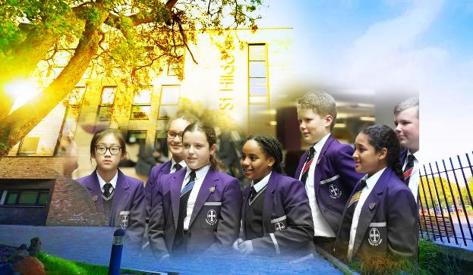

Welcome

Cleaner (part-time)
16.25 hours per week 3pm – 6:15pm all year round plus 3 inset days
SALARY RANGE: SCP 3 (£14.04ph)

CHRIST JESUS AS OUR
CORNERSTONE
THE ST HILDA’S FAMILY

Contents

Letter from the Head Teacher
About the school
Senior Leadership Team
Location
Job vacancy
Job Description
Person Specification
How to apply and the Selection Process
__________________________________________________________________________________

Strengths from SIAMS Report (2025)

- St Hilda’s family is deeply devoted to its vision. It is underpinned by a carefully crafted set of Christian values. These are the cornerstone of every aspect of this inclusive school community and enable students and adults to thrive together.
- Highly positive and productive relationships throughout the school nourish and affirm individuals enabling them to be the best that they can be. This is pivotal in transforming lives and encouraging an atmosphere of aspiration, hope and dignity.
- Religious education (RE) has a high status and is a significant strength of St Hilda’s.
Known throughout the school as ‘the core of the core’, it has a strong and challenging curriculum. Students flourish in the subject and make strong progress in their studies at all levels.
- Visionary leadership of collective worship inspires the school community and provides a key focus for its daily life. These times of gathering bring opportunities for reflection. They promote spiritual flourishing and strongly support the development of an understanding about how to live well.
- The vision passionately drives a culture that includes and nurtures every individual.
Therefore, leaders ensure that provision for students, including those with special educational needs and disabilities (SEND), is of the highest quality.

Dear Candidate
Many thanks for your interest in St Hilda's and the post of Cleaner (part-time).
St Hilda's is unique. St Hilda’s is a family. We are the only co-educational Church of England school in Liverpool in key stages 3 and 4. We welcome students and their family from a Christian background, from other faiths and those who have no faith. Each individual is precious.
Although our reputation in the community is excellent, this does not mean that we do not look for opportunities to improve who we are and what we do. We live by our values and are educating for 'wisdom, hope, community, dignity, equality and diversity'. Students helped to choose our 6th value of diversity. We changed to a house system to promote a sense of belonging in each of our students and members of staff. Our smaller House families come together to form the larger St Hilda’s family.
We chose our 6 Houses very carefully. Each one of these inspirational people embody our values and have helped to shape Liverpool. We speak in more detail about Margaret Aspinall, Gee Walker,
Kitty Wilkinson, John Brodie, William Roscoe and Levi Tafari on our website.
We believe in student voice, in student leadership and in high expectations. Our behaviour systems focus on a Chance to Change and we work hard in ensuring we support our students in making the right decisions, ready to take their place in our society. In 2025, Our SIAMS inspection found that
St Hilda’s Church of England High School is living up to its foundation as a Church school and is enabling students and adults to flourish. The report highlighted "St Hilda’s biblically rooted Christian vision is the cornerstone and lifeblood of this school family. It is strongly proclaimed and confidently embraced, sustaining and nourishing the school’s work and mission. Along with its compelling Christian values, the vision drives this exceptional school. Diversity and difference are embraced, giving dignity and allowing this community to live well together. Students are highly respectful and supportive, enabling them to appreciate and support one another to be who they are." We are unashamedly a Christian school. Our most recent Ofsted report graded us as Good in 2021.

We are heavily oversubscribed, but this does not mean that we do not recognise that we can become even better. We are looking for someone who will join the St Hilda's family in the key position of
Cleaner who champions all of our students, challenges where necessary and celebrates at every opportunity. You will support and develop the people in your team, ensuring all opportunities are taken to lead and share excellent practice. Your vision to support St Hilda's to the next level is paramount.
Academically, St Hilda's intake is above national average. However, our aspiration is that every single one of our students achieves or exceeds their potential, has exceptional pastoral support and has a wealth of opportunities to support their development. In this role, we are looking for a very special person with the vision and experience to help our vision become a reality. Is this you?
We welcome visits from prospective candidates, but this will not form part of the selection process. Please contact HR by email should you wish to arrange a visit recruitment@st-hildas.co.uk
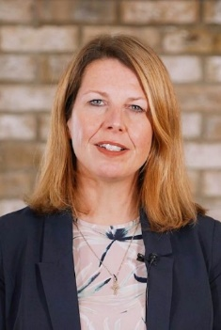
I look forward to receiving your application if you believe that St Hilda's suits your career aspirations and you meet our criteria for selection. We are looking for a very special Cleaner.
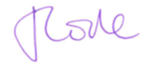
Thank you for your time,

Mrs Jo Code, Headteacher
St Hilda’s CE High School
St Hilda’s CE School is an 11-18 co-educational Church of England school that sits on the fringe of Sefton Park in Liverpool. The school currently has 1132 students. Due to parental demand for places at the school, from September 2018 we increased our Year 7 PAN from 150 to 170. We pride ourselves in being a fully inclusive school that serves our Diocese and beyond. Our vision encapsulates who we are as a school:
We are the St Hilda’s family, with Jesus Christ as our cornerstone.
Building on foundations of wisdom, hope, community, dignity, equality and diversity, we nurture and support each other to be or very best. We rejoice in our diversity and celebrate our many achievements.
St Hilda’s also has a sixth form. St Hilda’s College is an integral part of the school and last year, over 88% of Year 11 chose to continue their education at St Hilda’s. The College is growing year on year.


The new school buildings were opened in September 2015. We are incredibly proud of the excellent facilities we have, including excellent sports facilities. St Hilda’s College have dedicated areas in the school, including their own study rooms and café.
Our greatest asset at the school is our staff. St Hilda’s staff are incredibly generous with their time and support of each student. We have an incredibly low turnover of staff and we retain many of our ECTs and former students return to work here.
This is an exciting time to join the school and become part of a hard-working and committed team who embody our vision and values.
_________________________________________________________________________________

Leadership Team
Jo Code, Headteacher.
Karen Kearns, School Business Manager.
Robert Lawton, Deputy Headteacher, Pastoral.
Andy Smith, Deputy Headteacher, Quality of Education.
Carina Bird, Assistant Headteacher, Quality of Education, CPD.
Liz Cowdell, Assistant Headteacher, Quality of Education, Data & Assessments.
Andrea Howard, Assistant Headteacher, Head of St Hilda’s College.
Lisa Franks, Executive SENDCo.
John Martin, Assistant Headteacher, Behaviour and Attitudes.
Nancy Martin - Associate Assistant Headteacher, Head of Christian Distinctiveness & RE.
Conor Merrick, Associate Assistant Headteacher, Head of English, Literacy and Reading Intervention.
Ben Norton, Associate Assistant Headteacher, Early Careers and Appraisals.
Anthony Washington, Senior Head of House, Behaviour and Attitudes.
Karen Steele, Non-teaching DSL.
Kate Hester, SENDCo.
_________________________________________________________________________________

Liverpool
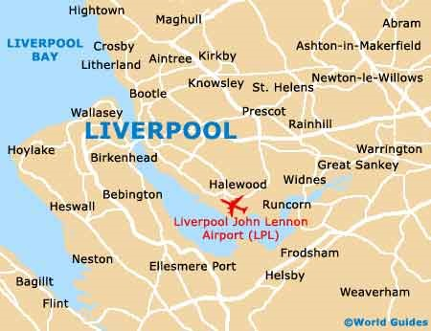
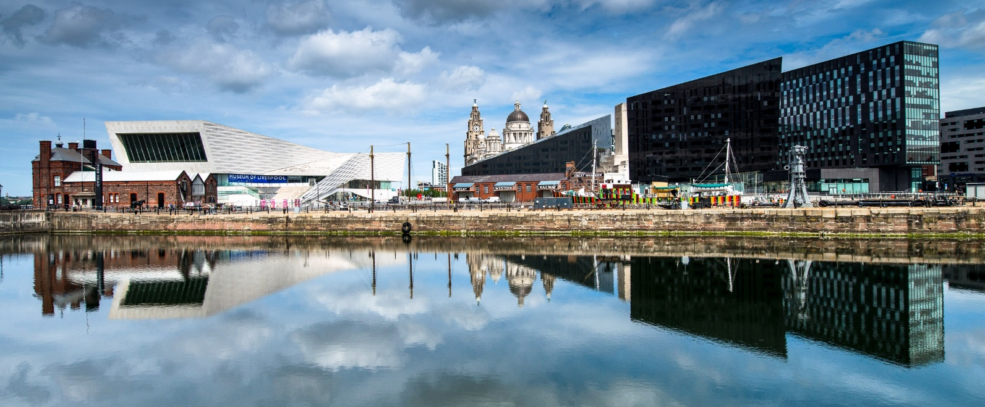
Liverpool is a city with unique attractions, exciting events, world class sport offerings, unrivalled musical heritage and a famously warm welcome!
Location and Transport Links
Liverpool enjoys superb communication links. St Hilda’s CE School is located close to the M62 and other major roads. There are train and bus links to St Hilda’s. Liverpool Lime Street train station is the main station serving the city of Liverpool. Liverpool Airport is less than 30 minutes away.
©Marketing Liverpool, Liverpool Docks 2
St Hilda’s CE High School
Croxteth Drive, Sefton Park, Liverpool L17 3AL
T: 0151 733 2709
E: info@st-hildas.co.uk
I: www.st-hildas.co.uk
Facilities and Amenities
St Hilda’s CE School is close to the 3 universities in Liverpool. We are also close to Liverpool One;
a range of shops, bars, restaurants, cafes and a cinema. Speke Retail Park and Edge Lane Retail Park are also close by.
Liverpool has the largest collection of museums and galleries anywhere outside London. The city also has several hospitals, theatres, cinemas and numerous other cultural and leisure facilities. St Hilda’s CE School lies in South Liverpool, overlooking Sefton Park.
Housing and Accommodation
A range of accommodation options are available in the local area and there is a thriving rental market. The excellent transport links allow many staff at the school to live in outside of Liverpool. Help and advice can be given by the school if accommodation is required.
_________________________________________________________________________________
Job Description
Whilst every effort has been made to explain the main responsibilities and duties of the post, each individual task to be undertaken will not be identified. Employees will be expected to comply with any reasonable request from a manager to undertake work of a similar level that is not specified in this job description. The job description is current to the date shown but, in consultation with you, it may be changed by the Headteacher to reflect or anticipate changes in the job commensurate with the grade and Job Title.

Cleaner
Working time: | 16.25 hours per week, part time 3pm-6.15pm, all year round
Grade: | NJC SCP 3, £14.04ph
Disclosure level: | Post is subject to a current enhanced disclosure
Reporting to: | Cleaning Supervisor, Facilities Manager
Working with: | All staff and students, parents and carers

PURPOSE OF POST
To be responsible for the general cleaning of the premises in accordance with the cleaning specification, under the direction of the Cleaning Supervisor, or other nominated person.

POST RESPONSIBILITIES
As a member of the St Hilda’s family, you will be expected to:

- Undertake individually or as part of the team, the cleaning of designated areas to ensure they are kept in a clean and hygienic condition. Duties will include: Cleaning, washing, sweeping, vacuum cleaning, emptying litter bins, polishing, and dusting of designated areas, which include toilet and associated facilities, fixtures and fittings, using where appropriate the necessary power equipment.
- To replenish consumables (toilet rolls, tissue paper, paper towels etc.) as part of the cleaning operation.
- To maintain and be responsible for the safe use and storage of all cleaning materials and equipment used in the course of his/her duties.
- To ensure that school users, members of the public and visitors to the school etc. or any such persons are informed of any situation or circumstances that may affect their health and safety while cleaning operations take place. The required Personal Protection Equipment (PPE) must be worn at all times
- To undertake relevant training where appropriate.
- To ensure that statutory requirements, codes of practice and procedures relating to the Health and Safety at Work and any other relevant enhancements are met in full.
- To provide cleaning cover for absent colleagues, at no extra cost, for up to five working days, after which time alternative arrangements will be made, should they be necessary
- To be available for school cleaning in the event of an emergency (e.g. flooding etc.) if and when required.
- To support the Head Teacher in promoting the Christian ethos of the school.
- Operate at all times within the stated policies and practices of the school
- Establish effective working relationships and set a good example through their presentation and personal and professional conduct;
- Co-operate with other staff to ensure a sharing and effective usage of resources to the benefit of the school, department and students;
- Contribute to the corporate life of the school through effective participation in meetings
- To promote equality as an integral part of the role and to treat everyone with fairness and dignity.
- To recognise health and safety is a responsibility of every employee, to take reasonable care of self and others and to comply with the school’s Health and Safety Policy
- To be willing to undertake First Aid Training
- To promote the welfare of children and to support the school in safeguarding children though relevant policies and procedures. Establish a purposeful and safe learning environment which complies with current legal requirements, national policies and guidance on the safeguarding and well-being of children and young people so that learners feel secure and sufficiently confident to make an active contribution to learning and to the school.
- Whilst every effort has been made to explain the main duties and responsibilities of the post, each individual task undertaken may not be identified.
- The job purpose and key statements remain indicative and by no means exclusive. Given the evolving needs of the school, flexibility among staff is very important. All staff may be required to undertake other such reasonable duties as may be required from time to time in line with the grade of their post.
- The post is exempt from the provisions of the Rehabilitation of Offenders Act and all convictions or cautions must be declared.

This job description is a guide to the duties and should be read in conjunction with the accompanying person specification.

This role involves contact with children and will be engaging in regulated activity relevant to children. This post is subject to an enhanced DBS disclosure check through the Disclosure &
Barring Service.
_________________________________________________________________________________

Person specification
In your letter of application under section 8 Person Specification, please demonstrate how you meet these criteria.
Do not include a curriculum vitae.
Candidates failing to meet any of the essential criteria will automatically be excluded.
r ability,
[A] Qualification requirements
 | Essential | Desirable | Source
No specific educational qualifications are required.  Experience of general cleaning activities. |  | D | A
Qualification in COSHH  First aid qualification  Other related qualification |  | D | A

- Knowledge/Understanding
 | Essential | Desirable | Source
Knowledge of Health and Safety issues (General) and Control of Substances Hazardous To Health (COSHH).  Able to undertake a range of manual cleaning activities.  Ability to maintain high standards of cleanliness in accordance with specified rotas. | E |  | A/I
Experience working within a school environment. |  | D | A/I
- Personal Qualities and Skills
 | Essential | Desirable | Source
Communicate effectively with both staff and students.  Ability to cope with periods of high demand and prioritise workload accordingly, meeting all deadlines.  Work flexibly and share in workloads, particularly during periods of high demand.  Hold positive values and attitudes and adopt high standards of professional behaviour.  Enthusiastic and positive.  Have a commitment to collaboration and co-operative working where appropriate.  Ability to work flexible hours on occasions.  Willing to undertake training courses that are relevant to the duties of the post or are required for Health and Safety reasons.  Willing to wear the prescribed personal protection equipment  Able to support the Christian ethos of the school  St Hilda's CE High School is committed to safeguarding and promoting the welfare of children and young people and expects all staff to share this commitment. | E |  | A/I

- Pre-Employment Checks
 | Essential | Desirable | Source
Positive recommendation from all referees, including current employer/ITT trainer | E |  | R
DBS Clearance post appointment | E |  | N/A

(Source: A=Application (form+letter); I=Interview; R=Reference)

[F] Application Form and Supporting Statement
The supporting statement should be clear, concise and related to the specific post. No more than 1 side of A4, font size 12.
Whilst every effort has been made to set out the main duties and responsibilities of the post, each individual task undertaken may not be identified.

_________________________________________________________________________________

Review date: 21.10.2026

How to apply and the Selection Process

Closing date: 9am, 4th November 2026
Interview: 9th November 2026
Applications should be sent to: recruitment@st-hildas.co.uk
All candidates, both those shortlisted and those who are not successful, will be contacted by email. Details of the date and time of final interviews will be given to successful candidates.

__________________________________________________________________________________



CHRIST JESUS AS OUR
CORNERSTONE
THE ST HILDA’S FAMILY
St Hilda’s CE High School
Croxteth Drive, Sefton Park, Liverpool L17 3AL T: 0151 733 2709 E: info@st-hildas.co.uk I: www.st-hildas.co.uk

St Hilda’s CE High School
Croxteth Drive, Sefton Park, Liverpool L17 3AL
T: 0151 733 2709 E: info@st-hildas.co.uk I: www.st-hildas.co.uk

Mrs J Code
BA (Hons), NPQH, FCCT
Headteacher

WISDOM
HOPE
COMMUNITY
DIGNITY
EQUALITY

