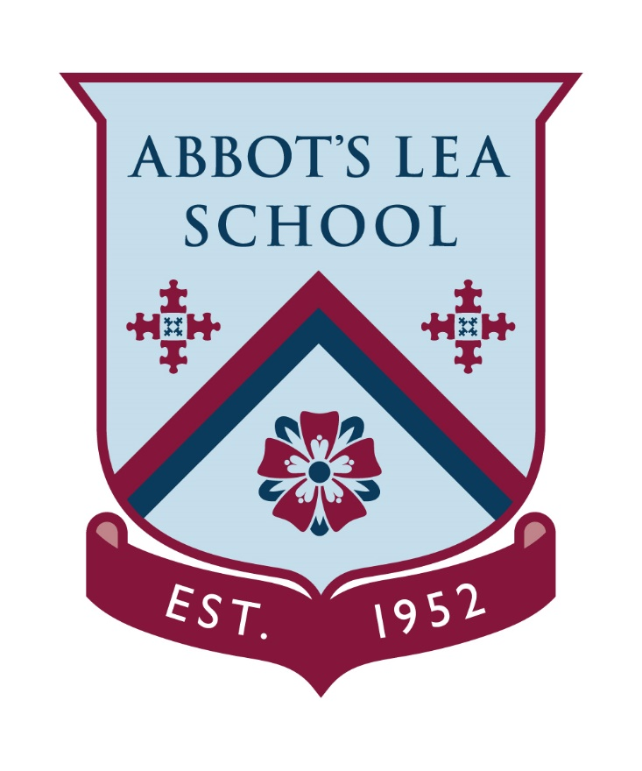

RECRUITMENT INFORMATION PACK

October 2026

Headteacher’s Welcome


Abbot’s Lea School is a highly successful, supportive and dynamic school providing young people aged 3 to 19, with Autism, a unique education for them to succeed personally, academically and socially in order to achieve their full potential.

Having joined the school in September 2016, I feel honoured to be its Headteacher and I will work tirelessly to make Abbot’s Lea the best specialist school in the world!

My personal motto is: “Work hard and be nice!” and I expect similar mind-set amongst my colleagues. In fact, our school’s Code of Conduct: The Golden Rules © specifies principles I highly value – both personally and professionally:

- Be here. Every day…
- Work hard and be nice
- Never give upon yourself or others
- Stay positive and be happy!
It is my firm belief that the staff are the most valuable asset of the school and so are integral in our working towards this vision. We all share a collective commitment to developing our young people, serving their families and ensuring that we lay the foundations for our students to be well equipped for their future adult life.

No matter what your role within the school, I will always look for a number of outstanding qualities in an ideal candidate for the team: an innovative and creative approach to work; enthusiasm, positivity and an unfaltering commitment to supporting our students’ success are key, as is an open-minded, proactive attitude towards working effectively in a team.

As a member of our team, you will receive ongoing support and development in your role and have access to a range of opportunities. We develop outstanding professionals, many of whom progress through the career pathway, joining us as Teaching Assistants and moving on to Higher Level Teaching Assistant roles with some choosing to enter the teacher training and leadership pathways.

I hope this pack provides you with everything you need to know about our vision, ethos and values, what you can expect from working at Abbot’s Lea School and the opportunities we will provide to support your career development.
I look forward to meeting you and answering any questions you may have.
Yours faithfully
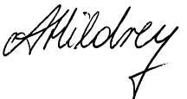
Mrs Ania Hildrey
Headteacher
E: headteacher@abbotsleaschool.co.uk
Why Abbot’s Lea School is unique

At Abbot’s Lea School, our aim is to ensure outstanding outcomes for all, including our students, their families and our staff.

Our students’ needs range from those with Autism and moderate learning difficulties, to those with Autism, severe learning difficulties, other complex needs and thereby requiring significant learning, pastoral and emotional support.

Our unique Philosophy of Education is known as The ASD Model ©. This underpins our promotion of students’ holistic growth in three key areas:

- Academic Progress
- Specialist Support
- Development of life skills

We seek to address the individual learning needs of all our students and to provide a broad and balanced curriculum. In addition, we have a wealth of resources and facilities to enhance students’ learning including our magnificent grounds with a newly installed outdoor learning area.

Our students have layered and complex needs which need to be met in order for them to successfully access learning and we have an in house team of exceptional professionals to deliver this.

Specific curriculum time is dedicated to the development of life skills for all students and we have a dedicated team who focus on employability and transition from school into adulthood.

Abbot’s Lea School fosters a culture where the achievements of both our staff and students are celebrated, praised and rewarded. The progress our students make is phenomenal and it is inspiring to see our students leave us and succeed beyond their school year.

What does Abbot’s Lea School have to offer you?

We believe the key to effective operation and development of the school is feedback from all staff and actively encourage this in our practice, from review of policies to planning of new playgrounds. Channels of communication are open at all levels with senior leaders operating an open door policy and one of our Governing Body committees being dedicated to Our Team and they meet termly with staff to understand and improve our working experiences.

Our staff value the professional and emotional support they receive from their peers and workload and wellbeing is a high priority for leaders. Workload is considered when implementing any new initiatives and mental and emotional health support is available via a number of channels, including Mental Health First Aiders.

We are a learning organisation and as such, we always look to develop our knowledge, skills and understanding of education, Autism and successful methods of working. We use the latest research in implementation of our efforts, and we actively engage in research opportunities within our school and with external organisations.

Continued Professional Development (CPD)

Professional development is important to us and plays a key role in allowing us to provide the best possible education to our young people.

Our staff will be supported through an induction period, where procedures and policies are disseminated and the expectations and key qualities shared. New members of staff can expect a thorough introduction to the school, from the physical layout, to the staff team, as well as support in identifying training needs and development opportunities.

Abbot’s Lea School may support the study of relevant professional qualifications, including the leadership development programme. All staff are also encouraged to engage in ongoing professional development based on their own research, professional reading and reflection and engage in professional supervision where appropriate.

Personal and enrichment benefits

There are many other advantages to working at Abbot’s Lea School, including:

- Pension scheme – Teachers Pension or Local Government Pension Scheme
- Cycle to Work scheme – a tax-efficient loan scheme to buy a bike and safety equipment for your commute to work
- Employee Assistance Programme – free and confidential staff advice and counselling service provided by Smart Clinic
- Family related benefits including maternity, paternity, adoption and parental leave
- Enhanced sick and parental pay schemes
- Subsidised gym membership (Liverpool City Council Lifestyles centres)
- Free on-site car parking
- Credit Union savings scheme
- Medicash benefit scheme

Location

We are situated in an excellent location in Woolton. Our location offers a unique blend of the town and suburbs allowing you to benefit from the urban and rural surroundings nearby - the best of both worlds. Please be aware that you may be required to work at alternative locations, should the school operate a satellite or split site provision.

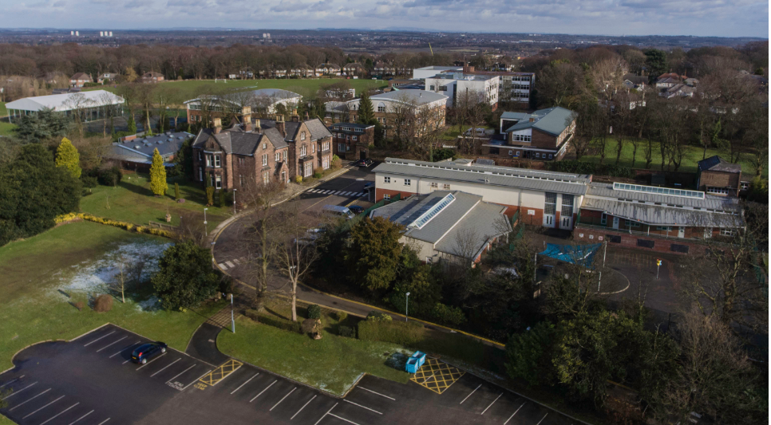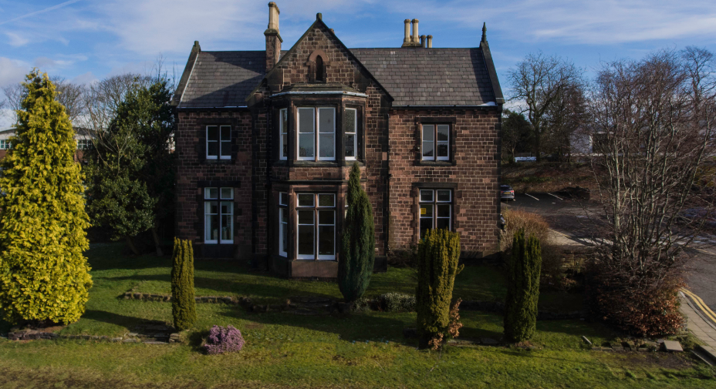
Our Organisational Structure

Meet Our Senior Leadership Team (SLT)

Current Vacancies and Recruitment Timeline:
www.abbotsleaschool.co.uk/vacancies

Further Information:

If you would like further information about the role or the school and would like to arrange a visit please contact our HR Manager Melanie Douglas via recruitment@abbotsleaschool.co.uk

Recruiting Contact:
Melanie Douglas, HR Manager
E: recruitment@abbotsleaschool.co.uk
W: www.abbotsleaschool.co.uk
Facebook: Abbot's Lea School
X: @AbbotsLeaSchool
LinkedIn: Abbot's Lea School

