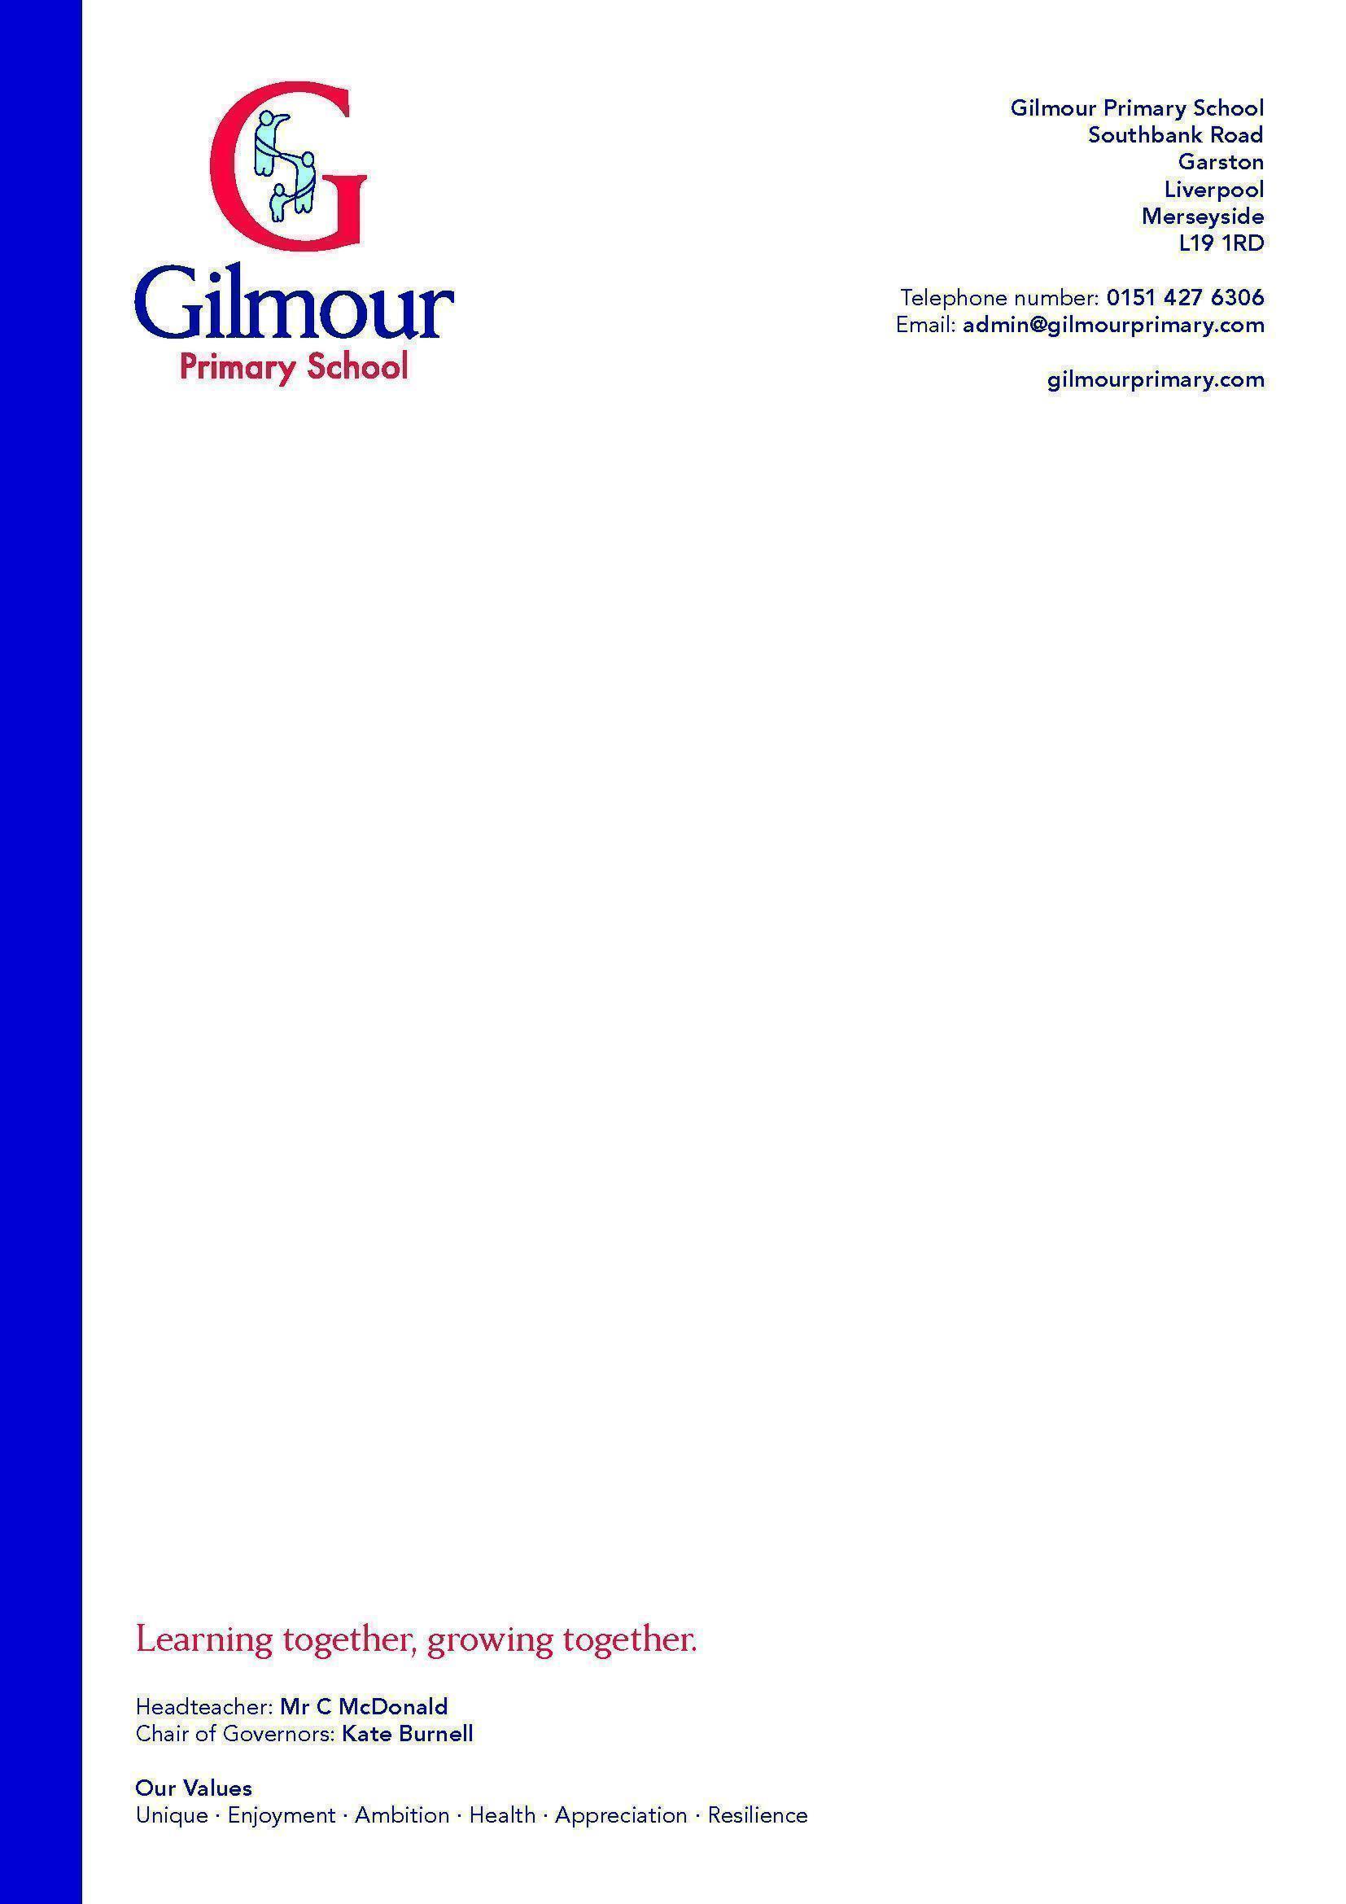
Main purpose of the role
To work in partnership with the class teacher to support learning by working with individuals or small groups of children under the direction of teaching staff.
Core responsibilities and tasks
- Implement planned learning activities/teaching programmes as agreed with the teacher.
- Adjust learning activities based on pupil’s responses as appropriate to achieve effective learning outcomes.
- Participate in planning and evaluation of learning activities with the teacher, providing feedback to the teacher on pupil progress and behaviour.
- Provide information to the teacher for monitoring, assessing and recording pupil progress/activities.
- To support learning by arranging/providing resources for lessons/activities under the direction of the teacher.
- Establish a productive working relationship with pupils, acting as a role model and setting high expectations.

- Liaise with other staff and provide information about pupils as appropriate.

- Understand and support pupils with special educational needs.

- The role may include some personal care.

- Assist with pupil first aid and welfare duties, looking after sick pupils, liaising with parents/staff etc.

Job Description
Level 2 Learning Support Assistant

