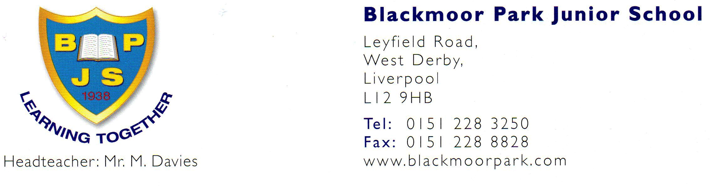
Head Teacher: Mrs. S. Harrison

Teaching Assistant/ Cover supervisor
Scale 3 depending on experience
Start date: January 2025
Term time only – 39 weeks per year
32.5 hours per week (8.30am to 3.30pm with ½ hour lunch)

Blackmoor Park Junior School is a friendly, three form entry junior school in West Derby. We are looking for an enthusiastic, reliable and adaptable TA/ CS who can support individual children with special educational needs, groups within classes and also lead interventions.
The team at BPJS are positive, creative and forward-thinking individuals who work hard to ensure every child enjoys school and achieves the very best they can. We are seeking someone who is an excellent role model, has a passion and commitment to supporting children with additional needs and someone who has strong spoken and written English and maths skills.
You will need to be:
- patient, caring and committed to the inclusion of pupils with SEND
- experienced in supporting children, particularly primary aged children
- an excellent communicator
- able to use a variety of strategies to get the best out of children
- enthusiastic, capable and able to use your initiative
- a great team player

For more information about our school, please visit the school website:
Home | Blackmoor Park Junior School
If you have any specific questions, please contact the School Business Manager, Pauline Handley, 0151 228 3250 or via email blackmoorparkj-ao@blackmoorpark-jun.liverpool.sch.uk
Closing Date for applications: Midday, Wednesday 17th December 2025
Interview date: Week beginning 12th January 2025
Blackmoor Park Junior School School is fully committed to safeguarding and promoting the welfare of children and young people and expects all staff to share this commitment. An enhanced Disclosure & Barring Service certificate will be requested for the successful candidate, references sought, and online checks will be made in accordance with Safeguarding Children and Safer Recruitment in Education legislation.

