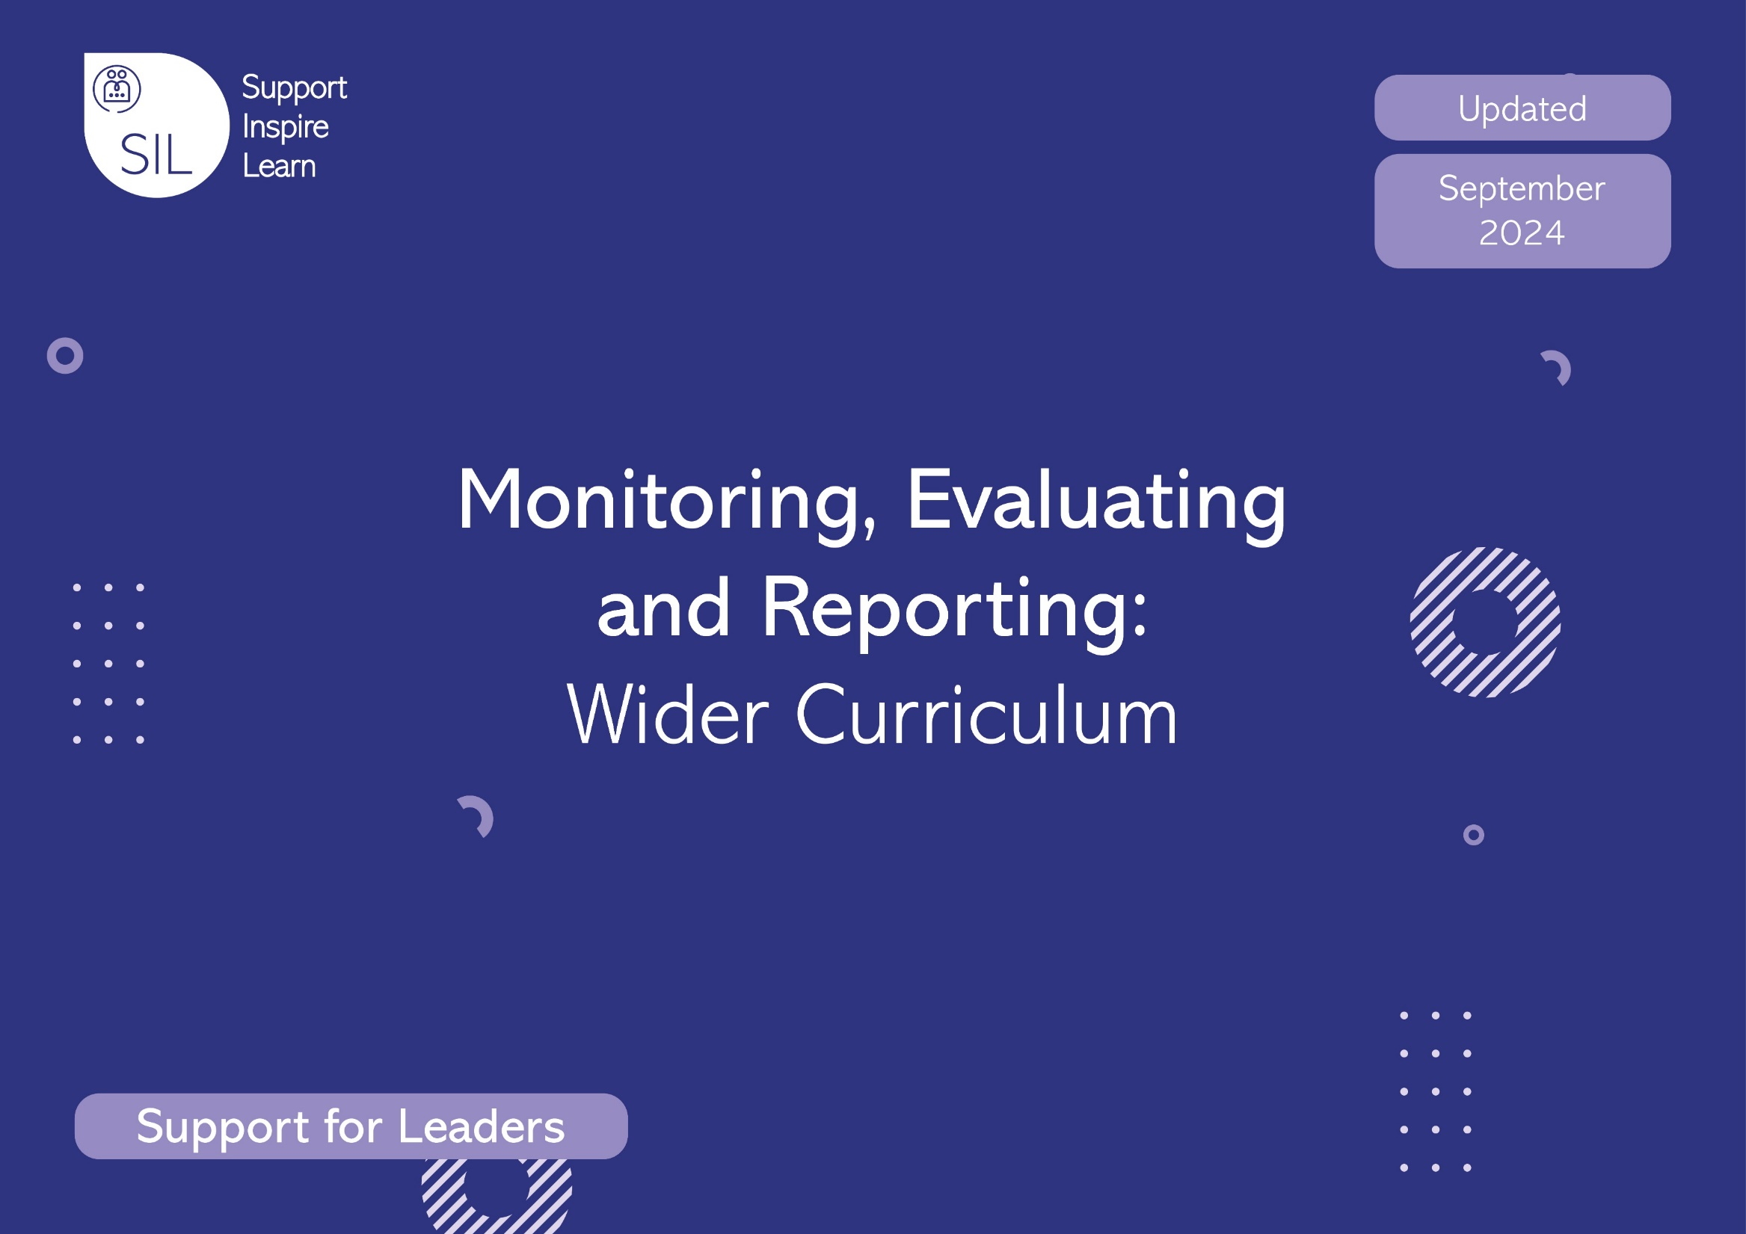



A Schools & Academies Show Gift from SIL
Support for Leaders

Writing

Living document regularly updated in response to DfE and Ofsted guidance.

Introduction
Monitoring, evaluating and reporting are processes that help to improve performance, and therefore, attainment.

- Monitoring provides useful information and evidence to assess ongoing performance; it helps to identify strengths and areas for development and leads to the planning of future actions.

- Evaluating is about reviewing the evidence and identifying ways to bring about further improvement.

- Reporting provides feedback on what is working well and areas that have been identified as needing further improvement.

The SIL Curriculum and Assessment Team has developed this document to support school leaders to:

- carry out monitoring activities that are focused and purposeful.
- evaluate evidence accurately.
- report findings through constructive feedback.

Schools may wish to use this document to support or complement current monitoring practice; it is not intended to be prescriptive, nor is it an exhaustive list of activities and questions. This is not intended to replace monitoring documents within your school’s chosen SSP.

Please use this section flexibly and amend it to suit your school’s priorities.

The complete digital resource - covering Phonics, Reading, Spoken Language, Mathematics, and the Wider Curriculum, can be ordered for £50 from our website.

Contents

  - Lesson Visit
  - Learning Walk
  - Pupil Voice
  - Whole School Work Scrutiny
  - Discussion with Staff
  - Subject Leader Questions
  - Learning Environment Audit
  - Evaluation of Monitoring

WRITING: Lesson Visit
Date: | Year Group: |  | Teacher: | TA: |  | Conducted by:
Focus and Context of Lesson:
Notes: Capture what you can see happening in the lesson. You may want to make a note of running time. Use the grid on the next page as a reference tool.
Consider
Behaviour for Learning |  | Appropriate Scaffolding |  |  | Teaching and Learning
- High expectations of pupils.  - High level of pupil engagement.  - Industrious atmosphere e.g., quiet working when appropriate, effective and well-structured partner talk, group work. |  | - Expectations are high for all pupils.  - Work pitched appropriately and teaching is adaptive  - In early stages of writing, pupils write only using the knowledge they already have.  - Oral composition supports the writing process and is well utilised  - Considered and meaningful scaffolding is in place and promotes independence.  - Appropriate resources and support enable all pupils to reach their full potential  - Skilled use of appropriately challenging models/exemplars in writing.  - Deliberate high-quality practice ensures that pupils build fluency in transcription (letter formation/handwriting and phonic application/spelling)  - The use of dictation supports transcription |  |  | - Secure subject knowledge.  - Effective teacher modelling supports pupils to progress at all stages of the writing process (from initial planning to published sharing their work).  - Vocabulary choices are well considered and delivered effectively.  - Lesson is organised coherently and forms part of logical teaching sequence.  - Appropriate content focus, teaching approach and activity choices help pupils to achieve the curriculum intent.  - Pupils have the existing knowledge needed to access new learning.  - Based on formative assessment.  - Teachers are clear about their curricular goal.  - Opportunity is given for pupils to read through their own writing or self/peer review.  - Opportunity for talk/oral composition.  - Verbal feedback is timely, specific and well considered.
Questioning |  | Other Adults |  |  | Environment
- Activates prior knowledge  - Appropriately challenging questions and responses  - Appropriate terminology and well-considered vocabulary  - Teachers effectively check for understanding  - Enables pupils to gain confidence in making links between writing, their own experiences and with texts read.  - Supports phonic application.  - Facilitates formative assessment. |  | - Effective, targeted deployment of other adults.  - Engagement with learners facilitates independence.  - Well trained, appropriate subject knowledge.  - Adults model writing effectively (transcription and composition).  - Adults model oral composition effectively (e.g. rephrasing, talking in full sentences) |  |  | - Working walls include phonics/spelling, vocabulary, modelled handwriting, examples of different print.  - Appropriate resources are readily accessible.  - Language rich environment (high quality talk) that helps to develop a love of writing.  - The learning environment offers calm, in which pupils can listen well and respond clearly, without distraction. Noise levels are appropriate to the task.
Next Steps: Include action points that recognise effective practice in place that could be shared with colleagues, as well as areas for development.

WRITING: Learning Walk
Date: | Year Group: | Teacher: |  | TA: | Conducted by:
Focus: e.g. consistency of approach, consistency in lesson structure, teacher subject knowledge, use of terminology
Notes: Capture what you can see happening in the lesson. You may want to make a note of running time. Use the grid on the next page as a reference tool.
N: |  |  | R:
Y1: |  |  | Y2:
Notes: Capture what you can see happening in the lesson. You may want to make a note of running time. Use the grid on the next page as a reference tool.
Y3: |  |  | Y4:
Y5: |  |  | Y6:

Consider:
Behaviour for Learning | Appropriate Scaffolding | Teaching and Learning
- High expectations of pupils.  - High level of pupil engagement.  - Industrious atmosphere e.g., quiet working when appropriate, partner talk, group work. | - Expectations are high for all pupils.  - Work pitched appropriately and teaching is adaptive  - In early stages of writing, pupils write only using the knowledge they already have.  - Considered and meaningful scaffolding is in place and promotes independence.  - Appropriate resources and support enable all pupils to reach their full potential  - Skilled use of appropriately challenging models/exemplars in writing.  - Deliberate high-quality practice ensures that pupils build fluency in transcription (letter formation/handwriting and phonic application/spelling) | - Secure subject knowledge.  - Effective teacher modelling supports pupils to progress at all stages of the writing process (from initial planning to published work).  - Vocabulary choices are well considered and delivered effectively.  - Lesson is organised coherently and forms part of logical teaching sequence.  - Appropriate content focus, teaching approach and activity choices help pupils to achieve the curriculum intent.  - Pupils have the existing knowledge needed to access new learning.  - Based on formative assessment.  - Teachers are clear about their curricular goal.  - Opportunity is given for pupils to read through their own writing or self/peer review.  - Opportunity for talk/oral composition.  - Verbal feedback is timely, specific and well considered.
Questioning | Other Adults | Environment
- Activates prior knowledge  - Appropriately challenging questions and responses  - Appropriate terminology and well-considered vocabulary  - Teachers effectively check for understanding  - Enables pupils to gain confidence in making links between writing, their own experiences and with texts read.  - Supports phonic application.  - Facilitates formative assessment. | - Effective, targeted deployment of other adults.  - Engagement with learners facilitates independence.  - Well trained, appropriate subject knowledge.  - Adults model writing effectively (transcription and composition). | - Working walls include phonics/spelling, vocabulary, modelled handwriting, examples of different print.  - Appropriate resources are readily accessible.  - Language rich environment (high quality talk) that helps to develop a love of writing.  - The learning environment offers calm, in which pupils can listen well and respond clearly, without distraction. Noise levels are appropriate to the task.
Next Steps: Include action points that recognise effective practice in place that could be shared with colleagues, as well as areas for development.

WRITING: Pupil Voice
Date: | Conducted By:
Focus area(s): What do you want to find out from this monitoring activity?
e.g. compliance to the medium-term plans, impact of the medium-term plans, enjoyment of writing, modelling of the writing process, modelling/teaching of transcription (handwriting and spelling)

Ensure you have access to medium term plans and that children have access to their workbooks.
Fostering a love of writing
Why is writing important? Do you enjoy writing? What do you enjoy about writing lessons? Do you ever have a choice in what you would like to write/how you would like to present your ideas (genre)? Do you get the opportunity to share your writing with others? Do you write for real purposes?
Current Learning
Tell me about what you have been learning about in your writing lessons. Show me/tell me about something that you have learnt that was new to you.
Writing Routines
Ask age-related questions to determine whether routines match the school’s policy and procedure:
Tell me about writing in your English lessons - what does this look like / what happens? How often do you write? How often do you talk through your ideas before actually writing on paper (oral composition)?
‘Remembering more’
Vocabulary:
What does this word mean? How are you supported to learn and remember new words?

Prior learning:
Have you ever learned about this aspect of writing/grammatical feature/genre before? How does your teacher support you to build your knowledge around writing?

Practice:
Do you have time to practise all stages of the writing process (plan, draft, re-draft, proofread, edit, publish)? Tell me about the last non-fiction / poem / fiction that you wrote? Do you have the opportunity to talk through ideas before writing (oral composition)? Do you have time to practise spelling and handwriting?
Writing across the curriculum
Ask questions to elicit whether:
- pupils have the chance to write in more depth, learning at their own pace.
- writing across the curriculum motivates them to further develop their learning independently.
- they are motivated to write fiction and non-fiction linked to the subject they are studying.

WRITING: Whole School Work Scrutiny
Date: | Conducted by:
Focus: (e.g. consistency of approach, appropriate practice, adherence to agreed policies)

Evidence might include: Individual work-books, wider curriculum books, online evidence (videos, SeeSaw, etc)

 |  | Y1 | Y2 | Y3 | Y4 | Y5 | Y6
Building on Previous Learning

A logical teaching sequence, built upon prior learning is evident.
There is progression across:
- Text types (genres -complexity), vocabulary, grammar and punctuation, spelling, letter formation/handwriting, sentence construction
- Pupil writing (show increased sophistication)
Pupils’ transcription (spelling and handwriting) is purposely developed so that over time spelling and letter formation/handwriting becomes more accurate and automatic (transcription fluency).
Pupils’ composition skills are logically and sequentially developed.
Tasks allow pupils to deepen their knowledge of writing and make connections to prior knowledge.

Depth and Breadth of Coverage

Carefully considered vocabulary is identified, taught, explored in different contexts, revisited and applied
Pupils’ work shows that they access a suitably broad range of text types within their writing, including fiction, non-fiction and poetry.
Pupils’ work shows that they write for a range of audiences and purposes (as outlined in appropriate NC year group statutory requirements).
Pupils work shows knowledge of grammar and vocabulary including Standard English (spoken and written) and matches Appendix 2 of NC PoS.
Pupils are encouraged to develop their coherence/cohesion in writing.
Regular evidence of planning, drafting, editing and proofreading as part of the teaching sequence and pupils have opportunities to practise, refine and evaluate their work.
Tasks allow pupils to deepen their knowledge, understanding and mastery of writing composition and transcription
Pupils’ Progress

Pupils make strong progress from their starting points.
Pupils’ work shows that they have developed their knowledge and skills over time (including phonic application)
Practice

Pupils are regularly given opportunities to revisit and practice what they know to deepen their understanding.
Dictation is used to help pupils revisit and practise new learning in transcription in order to develop fluency (particularly in KS1 and into LKS2).
Vocabulary is identified, taught, applied and revisited.
Any misconceptions are addressed and there is evidence to show that pupils have overcome these in future work. This might include self-correcting in comprehension monitoring or decoding on a video. This might include correcting grammatically incorrect sentences, or spelling errors.
Summary

Points from previous monitoring have been addressed.
School Policies are adhered to.
Strengths (may include aspects that could be shared with other colleagues as good practice).
Areas for development (including focus for next monitoring and date).

WRITING: Discussion with staff
Conducted by: | Date:
Teacher/Adult:
Focus area(s): What do you want to find out from this monitoring activity?
e.g. the impact of current planning/procedures, compliance to the medium-term plans, impact of the medium-term plans, enjoyment of writing, transcription fluency, writing for audience and purpose, oral composition

Fostering a Love of Writing
Ask a range of questions to determine:
- How adults are promoting a love of writing.
e.g. What is the general attitude towards writing within your class? How are writing activities received by the children in your class/group? How do you try to inspire a love of writing within your pupils? How does your environment foster a love of writing?

Writing Routines
Ask a range of questions to determine:
- Which writing routines are well established and consistent in delivery in terms of timetabling, expectations and school policies. Include questions about letter formation/handwriting, phonic application/spelling, vocabulary, grammar and punctuation, composition, spoken language, reading into writing.
e.g. Tell me about established writing routines in your class. Talk me through what writing provision is in place on an average day. How do you support pupils to practice their writing? What does writing across the curriculum look like in your class?

Current Teaching
Ask a range of questions to determine:
- How the school’s writing curriculum informs their choices about content and sequencing to support pupils’ learning.
e.g. What are you teaching in writing at the moment? How is the teaching of writing sequenced? How do you support pupils to build on prior learning? How do you use formative assessment to adapt teaching?

CPD
Ask a range of questions to determine:
- Confidence levels and possible CPD needs in the teaching of writing.
e.g. How do you support pupils to become fluent writers? How do you support pupils to improve their automaticity? How do you develop pupils’ writers’ voice? How do you develop pupils’ vocabulary? How do you support pupils to draw on background knowledge? How confident are you in teaching these areas of writing? How do you teach sentence construction?

Writing Assessment
Ask a range of questions to determine:
- How agreed assessment practices are implemented and analysed and whether there is any support needed.

Next steps:

WRITING: Subject Leader Questions to Consider
Use these questions to ensure that you are confident to talk about writing in conversation with SLT and key stake holders, or during inspection.
What did you learn from your last monitoring activities and what action did you take?
What is working well? What are the strengths of your reading writing curriculum?
What are your key priorities for this year?
How do you, as subject leader, ensure the writing curriculum is well sequenced?
How is practice and the revisiting of prior learning built into long term planning?
How do you support pupils to develop their composition? How does it build progressively, including the construction of sentences?
How do you support pupils to develop transcription fluency? How does it build progressively?
How do the teachers ensure the children have learned the content set out for them?
What happens when a year group falls behind in coverage?
How is assessment used to inform planning?
How are the foundations for reading writing taught and developed in EYFS?
What elements do you expect to see in a writing/English/grammar/spelling/handwriting lesson in your school?
How do you ensure planned vocabulary is taught, practised and applied?
How do you ensure that there are regular opportunities for all pupils to engage in practice to build writing transcription fluency?
How do you ensure that all children are challenged and supported to become fluent writers?
Some aspects of writing need to be automatic (almost done without thinking). How do you decide what they are, and the approaches you will use to develop automaticity?
What support is in place for pupils working below age-related expectations?
How do you ensure a pupil who is behind in reading is able to access the writing curriculum?
What CPD have you and your staff had and what has been the impact?

WRITING: Learning Environment Audit
School: | Date: |  | Conducted By:
Focus:

Classroom Environment
Working walls
Do they provide effective scaffolding for children? Do they represent the current stage in the teaching sequence? Are they in line with school policy? Are they visible/accessible for all children? Are children using the working wall? How do you know? Do they support spoken language for composition?

Resources
Are they meaningful and purposeful? Are they appropriate for the stage of writing? Do they promote independence/self-scaffolding?
Do resources match the school’s chosen SSP? Do resources support pupils with pencil grip and posture? Are there appropriate writing implements available for different tasks in every class?

Displays
Do they promote a love of writing? Is writing evident in displays for other curriculum subjects? Do they celebrate writing? Do they capture elements of the writing process? Is writing used appropriately to capture/celebrate learning in other subjects? Is there a variety of environmental print, including the school’s chosen letter formation for handwriting, on display?

School Environment
Displays
- Do displays celebrate writing and the writing process?
- Do they represent a wide range of writing?
- Is writing used appropriately to capture/celebrate learning in other subjects?
- Do displays allow children to share their writing with a wider audience, for example, writing ‘published’ shared in class books in the library or reception area?
- Is transcription fluency evident through displays?

Next Steps:

WRITING: Evaluation of monitoring
Date:
Outcomes from this document reported to/shared with:
(e.g. Senior Leaders, Teachers, All Staff, Governors)

On:
(Date shared)
 | Key Strengths | Key Areas for Development
Lesson Visit
Learning Walk
Pupil Voice
Whole School Work Scrutiny
Discussion with Staff
Subject Leader Questions
Learning Environment

Whole School Next Steps:

