Language Networks Now: Living the Language
Language Education in the Northwest and Beyond: Exploring Collaborations
University of Liverpool
ULMS (Management School Building) SR5
9 June 2026, 13.00-17.00
Registration link

13.00 Arrival and registration for afternoon delegates
13.30 Welcome: Prof Sophie Fuggle (Head of Department of Languages, Cultures and Film)
13.40 Languages in Liverpool and the North-West: The current situation, Gill Rowlands, SIL (formerly School Improvement Liverpool)
14.00 School – university collaborations
LanguagesForAll – A Social Justice Issue (Claudia d’Agostino, Languages for All)
The Languages Gateway (Dr Ian Ellison, University of Oxford and University of Liverpool alumni)
Outreach activities and Routes (Prof Anna Saunders, University of Liverpool)
14.30 Modern Languages in Schools (Jo Code, Headteacher, St Hilda’ CE High School)
15.00 Teacher pipeline initiatives at the University of Liverpool – Placing language degree students in schools
15.15 Our multilingual language learners: What “Saturday schools” and community language learning can do for schools
15.30 Refreshments and networking
16.00 Panel discussion: Language Education in the Northwest: Cold Spots, Challenges, Opportunities and Collaborations
In this session we will explore new ways of working to make the North-West a truly multilingual region. What can we do to foster new and already existing language skills and what can we do to accredit them appropriately for the benefit of the students?
16.30 Summary and conclusions
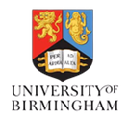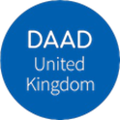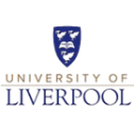
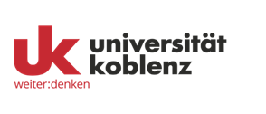

Book of Abstracts and session previews

Teacher pipeline initiatives at the University of Liverpool – Placing language degree students in schools
Ana Bela Almeida (University of Liverpool), Michael Cummings, Head of MFL, St Hilda’s CE High School) + UoL final year students
In this session language students from the University of Liverpool and schoolteachers working with students will discuss placements in schools. Do they have an impact on the students’ career decisions? How do the schools benefit?
The participants worked in schools as part of the module Language Teaching – Theory and Practice, or on British Council Teaching assistantships during their residence abroad.

Our multilingual language learners: What “Saturday schools” and community language learning can do for schools
Speakers tbc
Many Saturday schools provide essential supplementary language classes, often to maintain and develop the students’ already existing language skills. In this session we will explore ways to work together more closely with schools.

Panel discussion: Language Education in the Northwest: Cold Spots, Challenges, Opportunities and Collaborations
In this session we will explore new ways of working to make the North-West a truly multilingual region. What can we do to foster new and already existing language skills and what can we do to accredit them appropriately for the benefit of the students?

